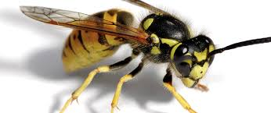Pest Problem?
Expert Pest Control
18 yrs experience
Usually same day service
Incl weekends
Call David 07833459321
d_jess_85@hotmail.com

